Task on Terraform-4
1).Watch Terraform-04 video.
Complete watching the video
2). Execute the script shown in the video.
Version constrains
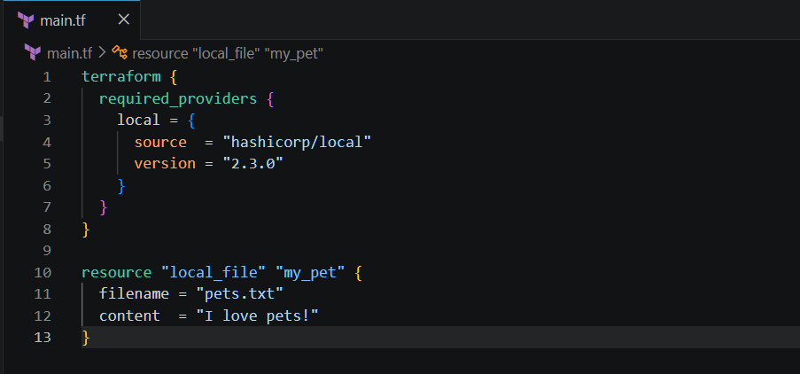
Here we can see that it is downloading the given version from the configuration
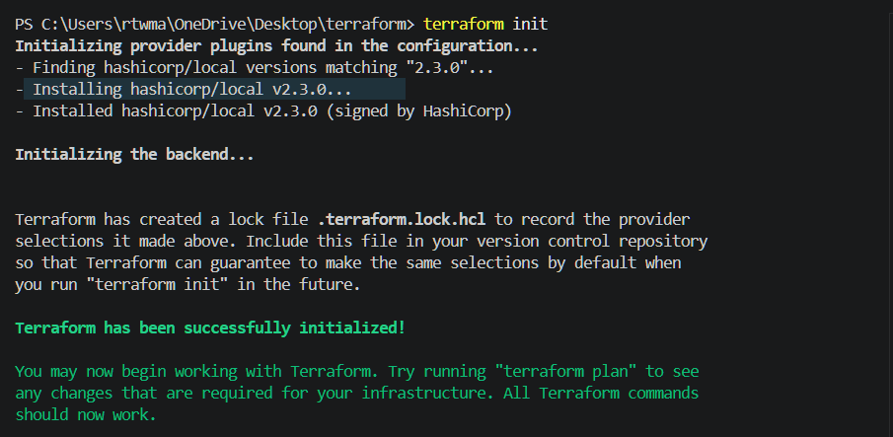
We can see the pets.txt file is created
Terraform apply
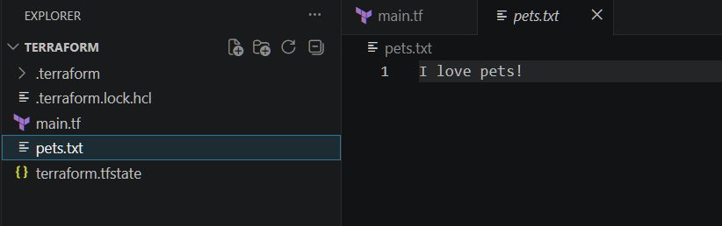
Now lets download different version
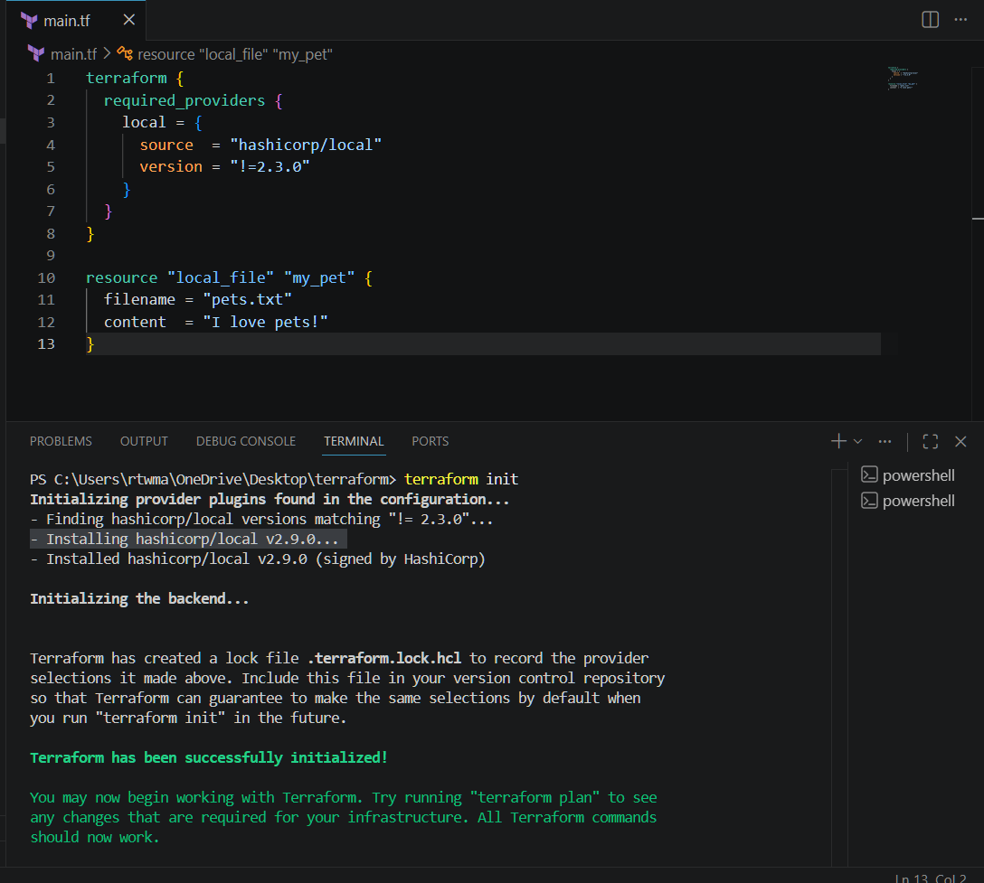

Now lets download for version less than 2.3.0
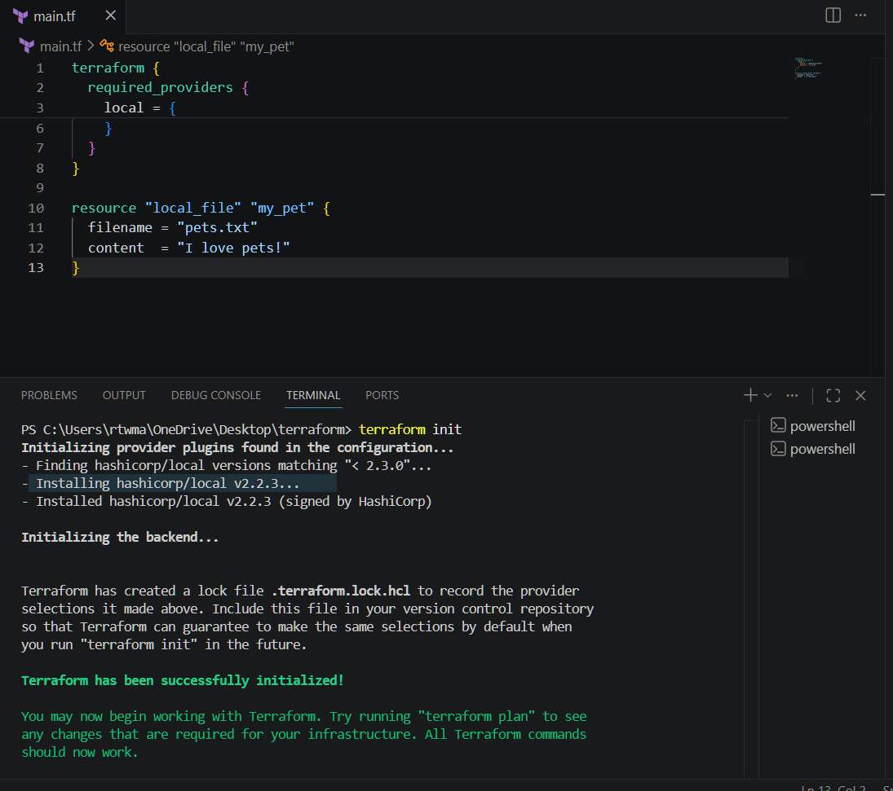

lets download the version greater than 2.3.0
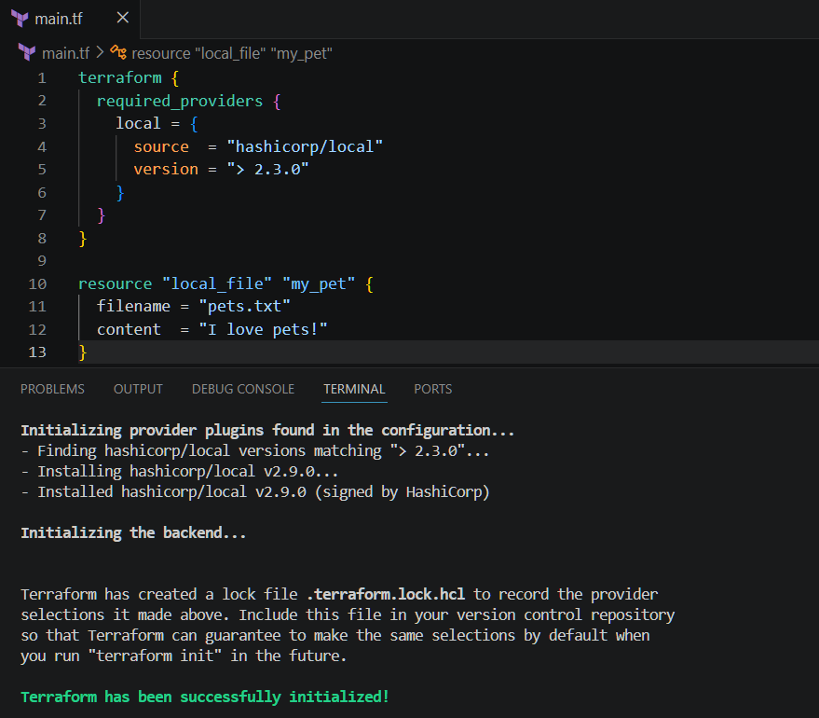

version = "~> 2.3.0" --> specific version or higher version.
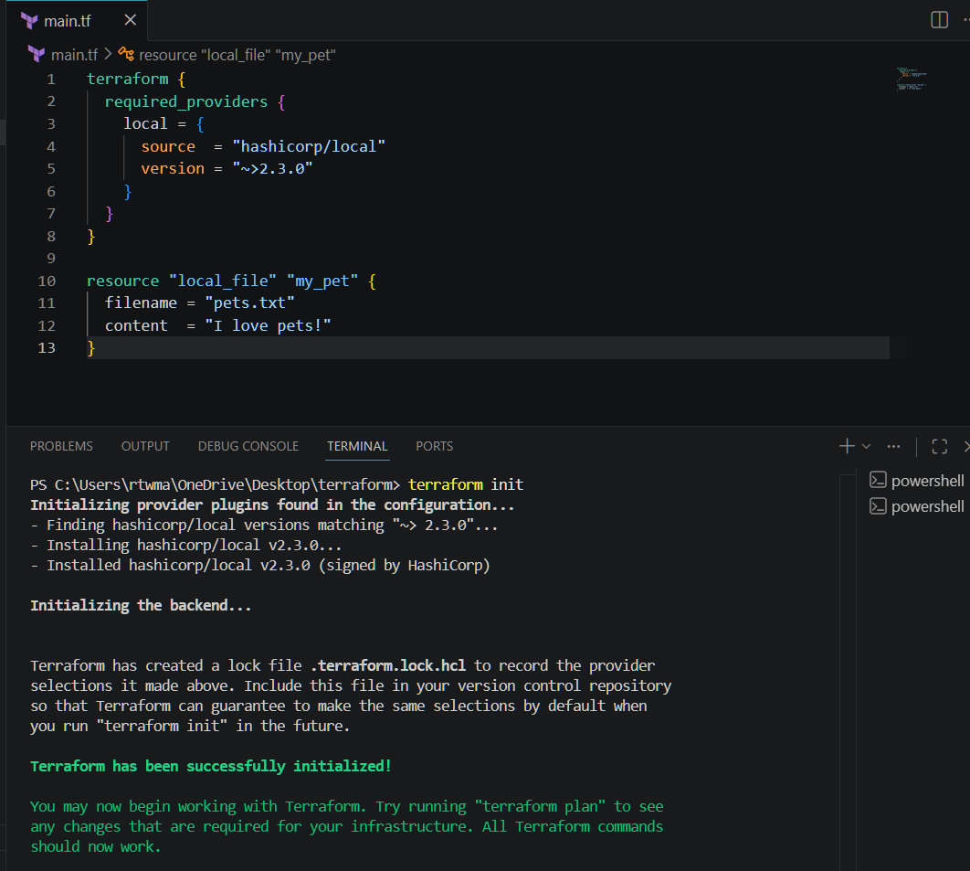
Data source
Data source is used to read the existing infrastructure, it won’t create any files
Created a new file as dogs,txt and added content in that
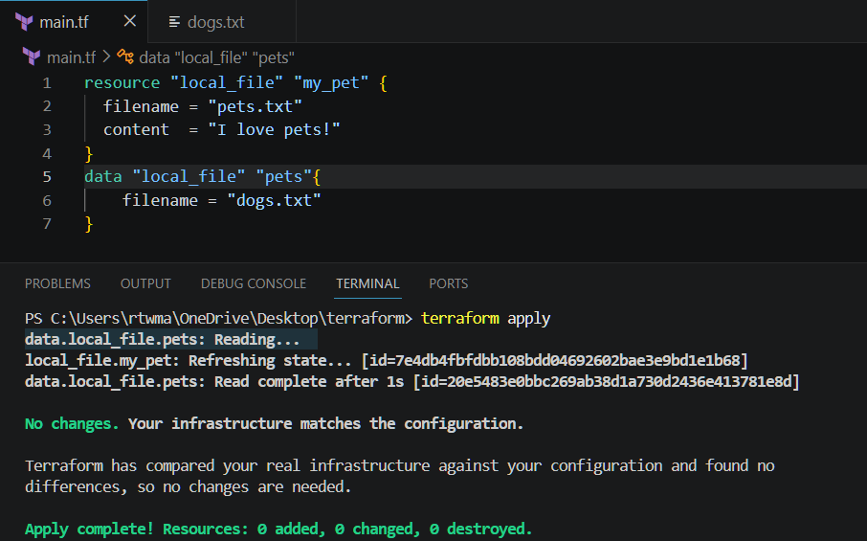
Meta Arguments
4 files are created
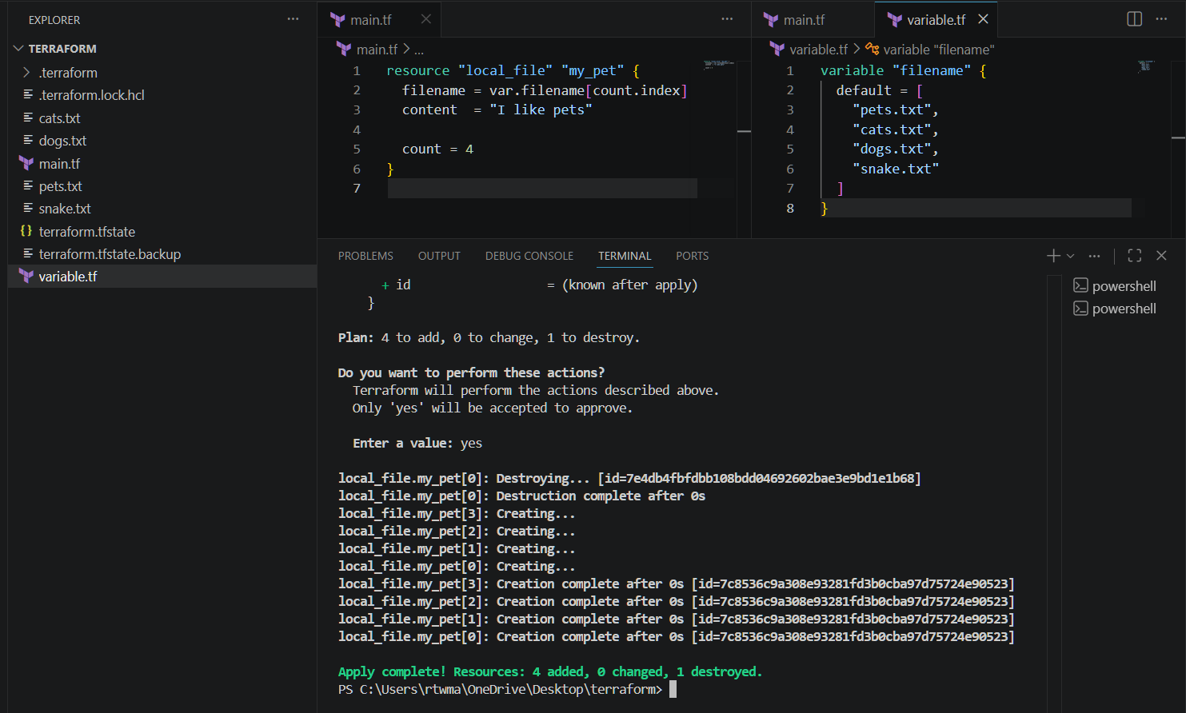
Now lets destroy two files
Files deleted succesfully
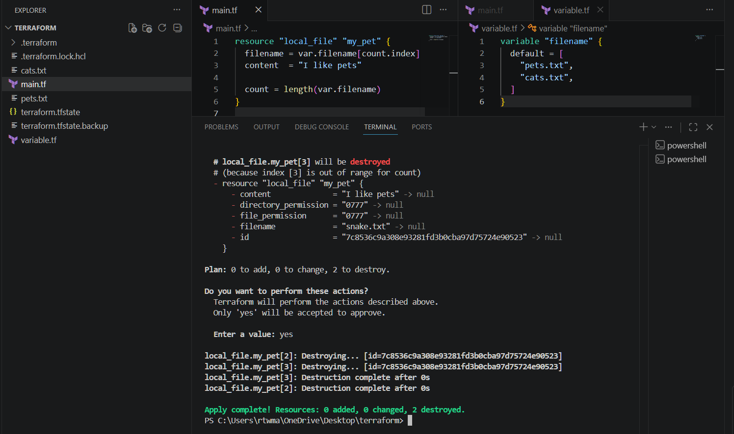
If we don’t want to use the inbuilt function we can include type in variable.tf
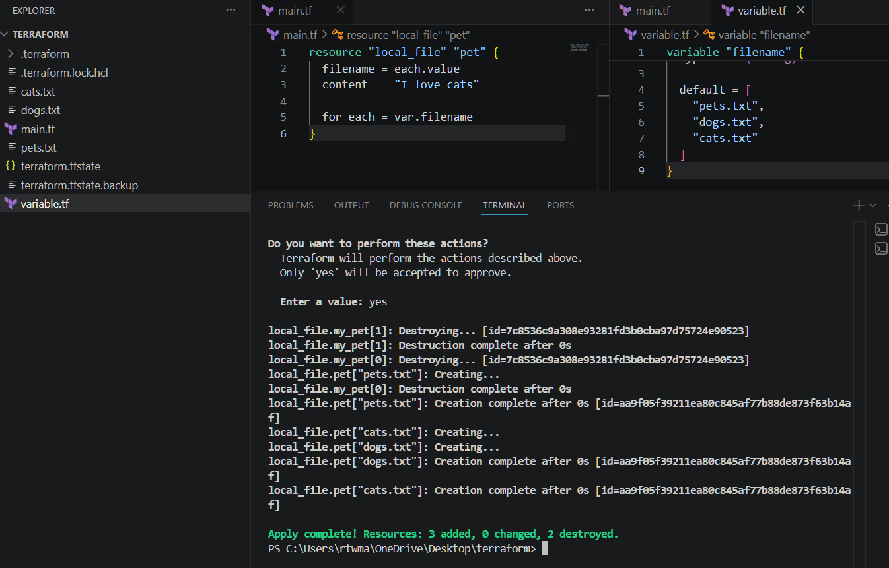
Let’s create user and policy
provider "aws" {
region = "us-east-1"
}

# Create IAM User
resource "aws_iam_user" "dev_user" {
name = "terraform-dev-user"
}

# Create Custom IAM Policy
resource "aws_iam_policy" "custom_policy" {
name = "CustomS3ReadOnlyPolicy"
description = "Allow read-only access to S3 buckets"

policy = jsonencode({
Version = "2012-10-17"
Statement = [
{
Effect = "Allow"

Action = [
"s3:ListBucket",
"s3:GetObject"
]

Resource = [
"arn:aws:s3:::*",
"arn:aws:s3:::*/*"
]
}
]
})
}

# Attach Policy to User
resource "aws_iam_user_policy_attachment" "attach_policy" {
user = aws_iam_user.dev_user.name
policy_arn = aws_iam_policy.custom_policy.arn
}

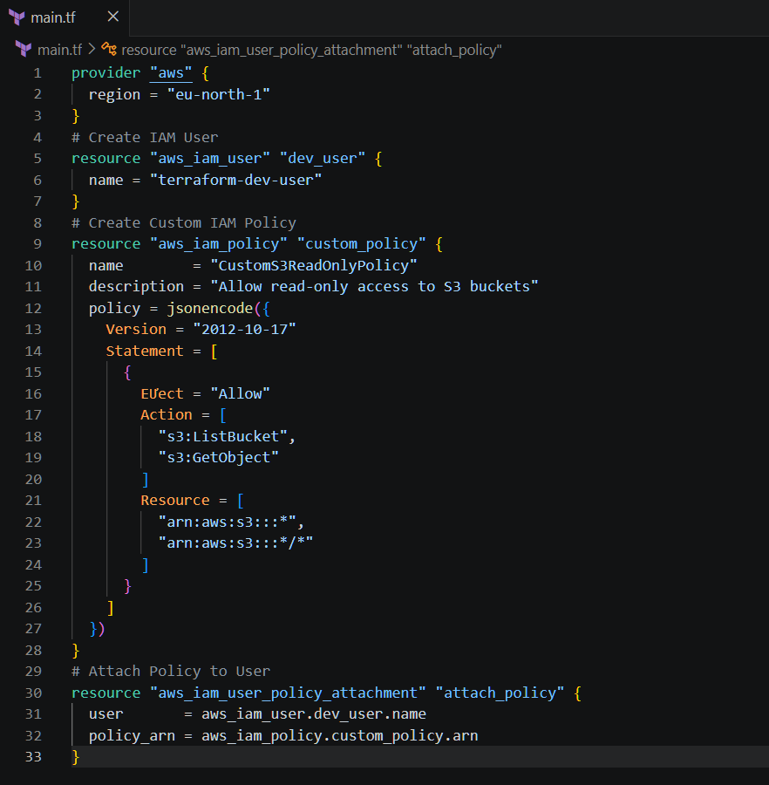
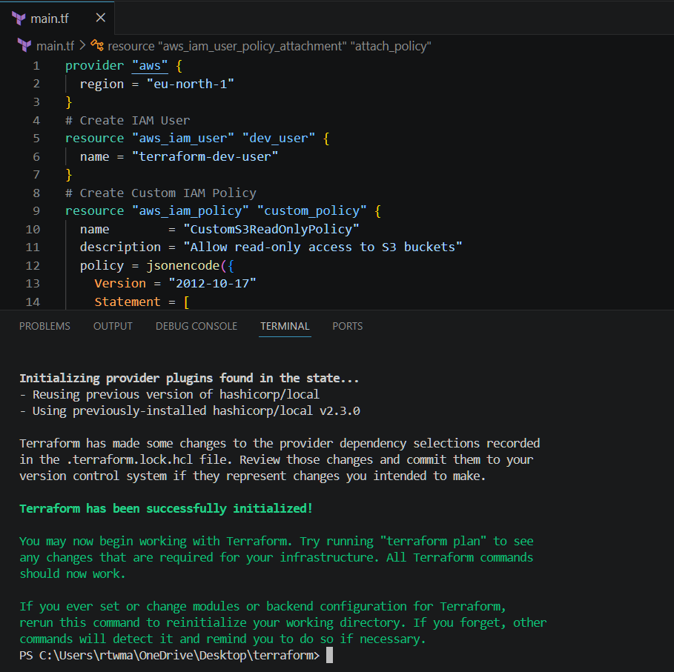
terraform fmt
terraform validate
terraform plan
terraform apply
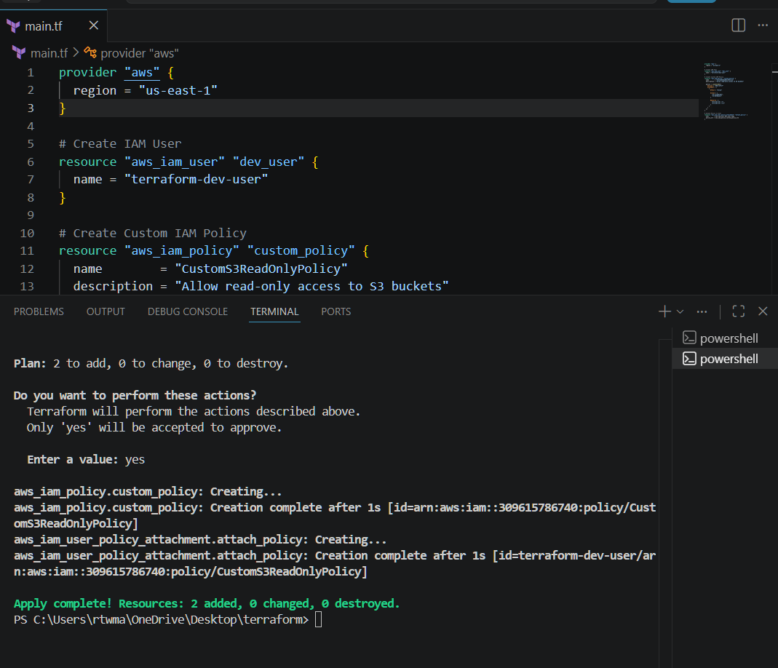
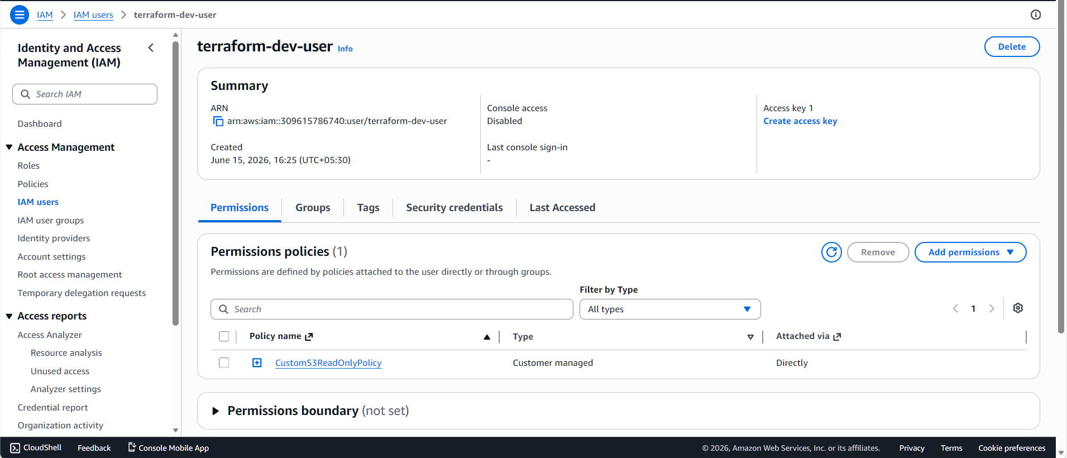

3). Integrate Terraform in Jenkins using the Terraform plugin.
Installed terraform plugin
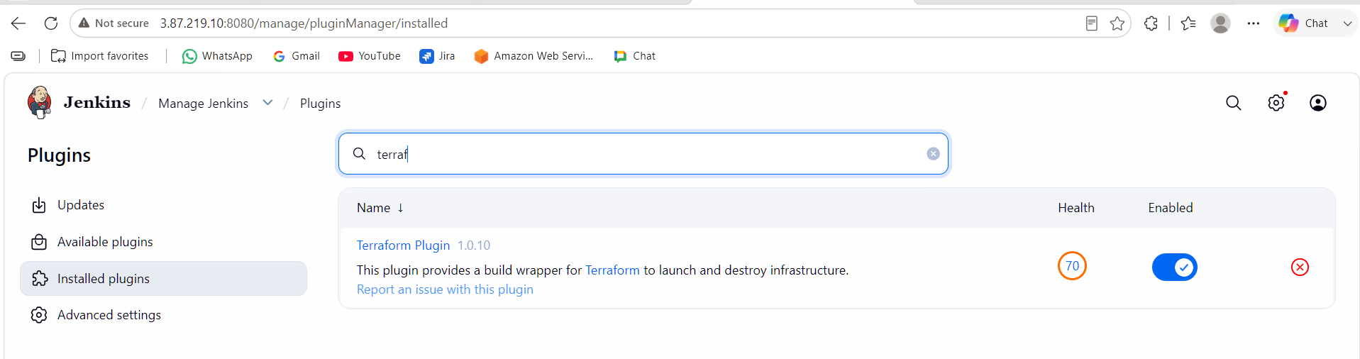
Tools terraform installation give name save
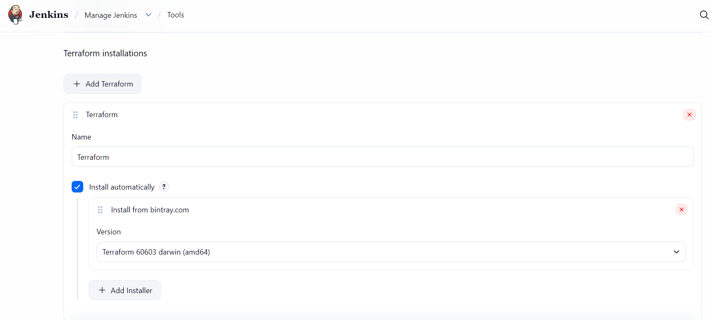
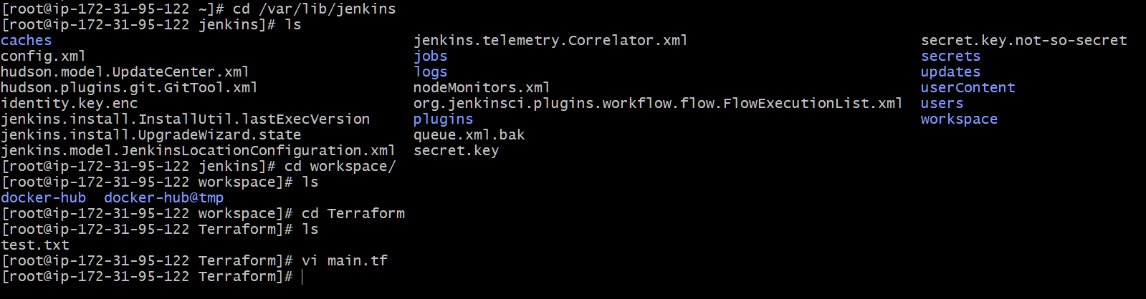
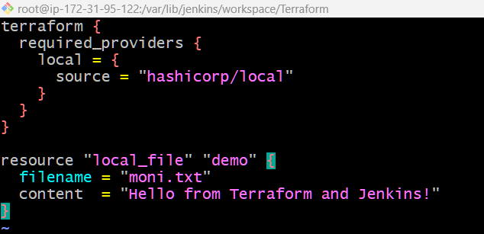

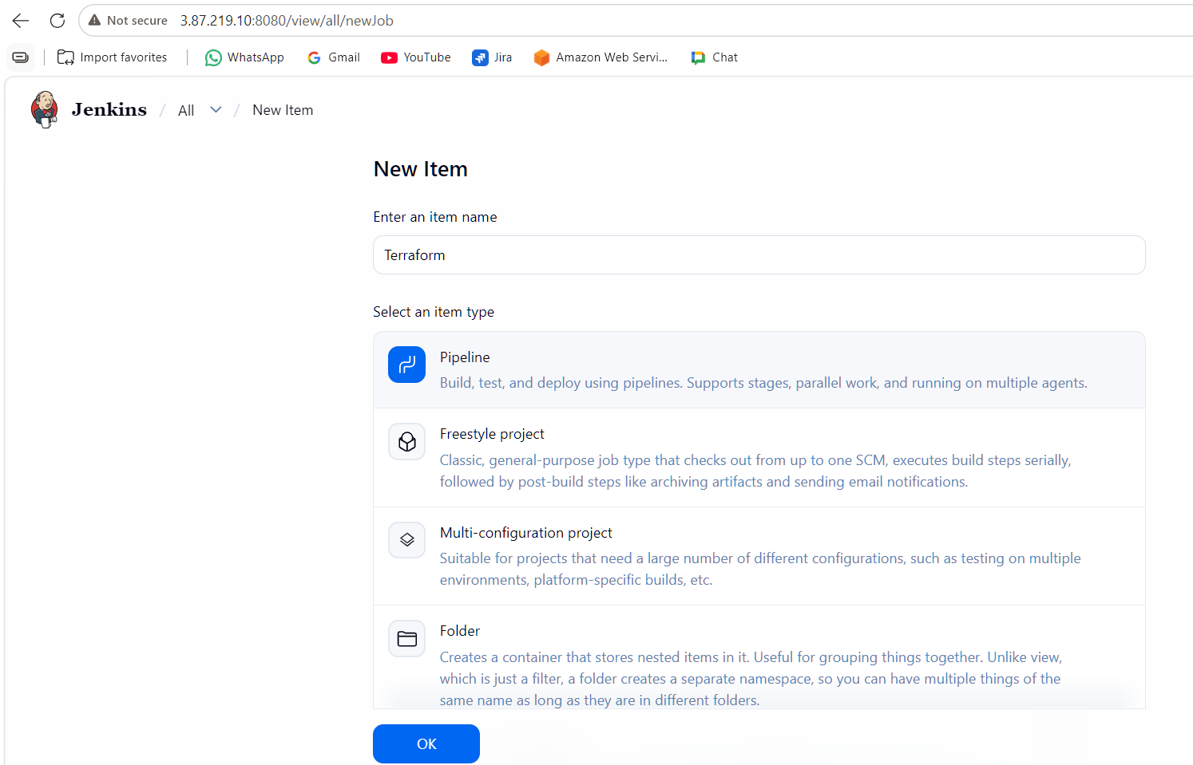

The pipeline is build successfully
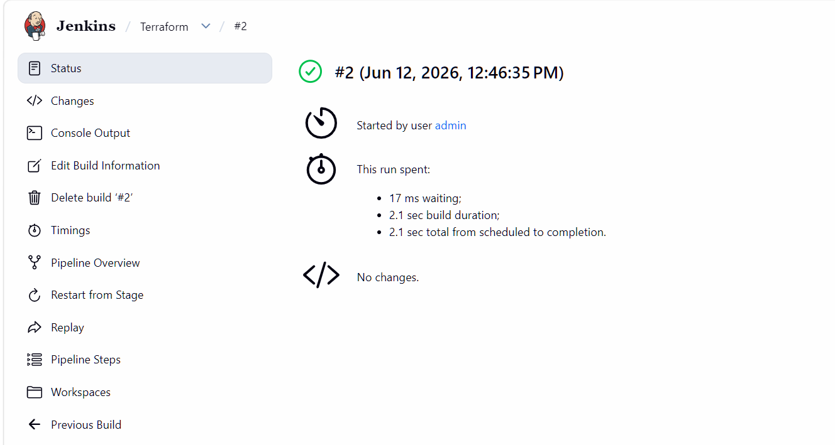
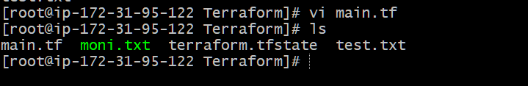
4). Create a CI/CD pipeline for a Nodejs Application: https://github.com/betawins/Trading-UI.git
Sudo yum update -y
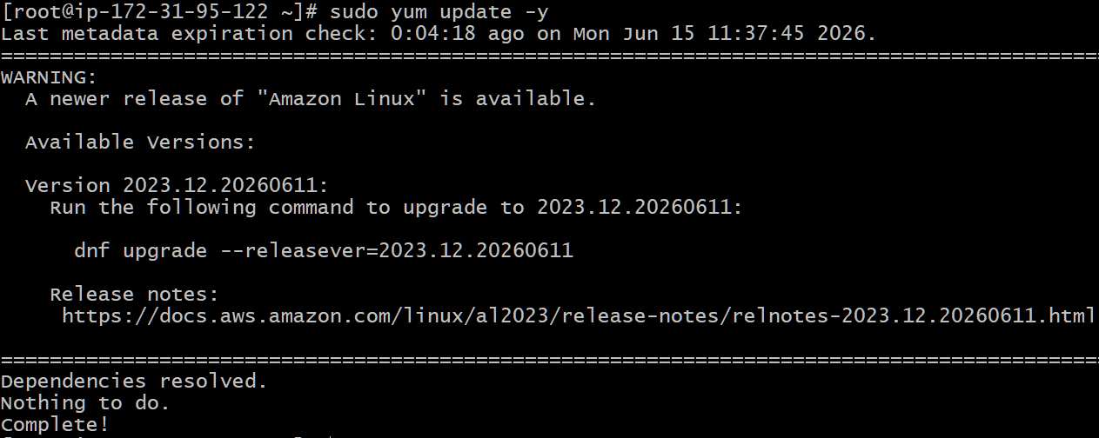
sudo dnf install -y nodejs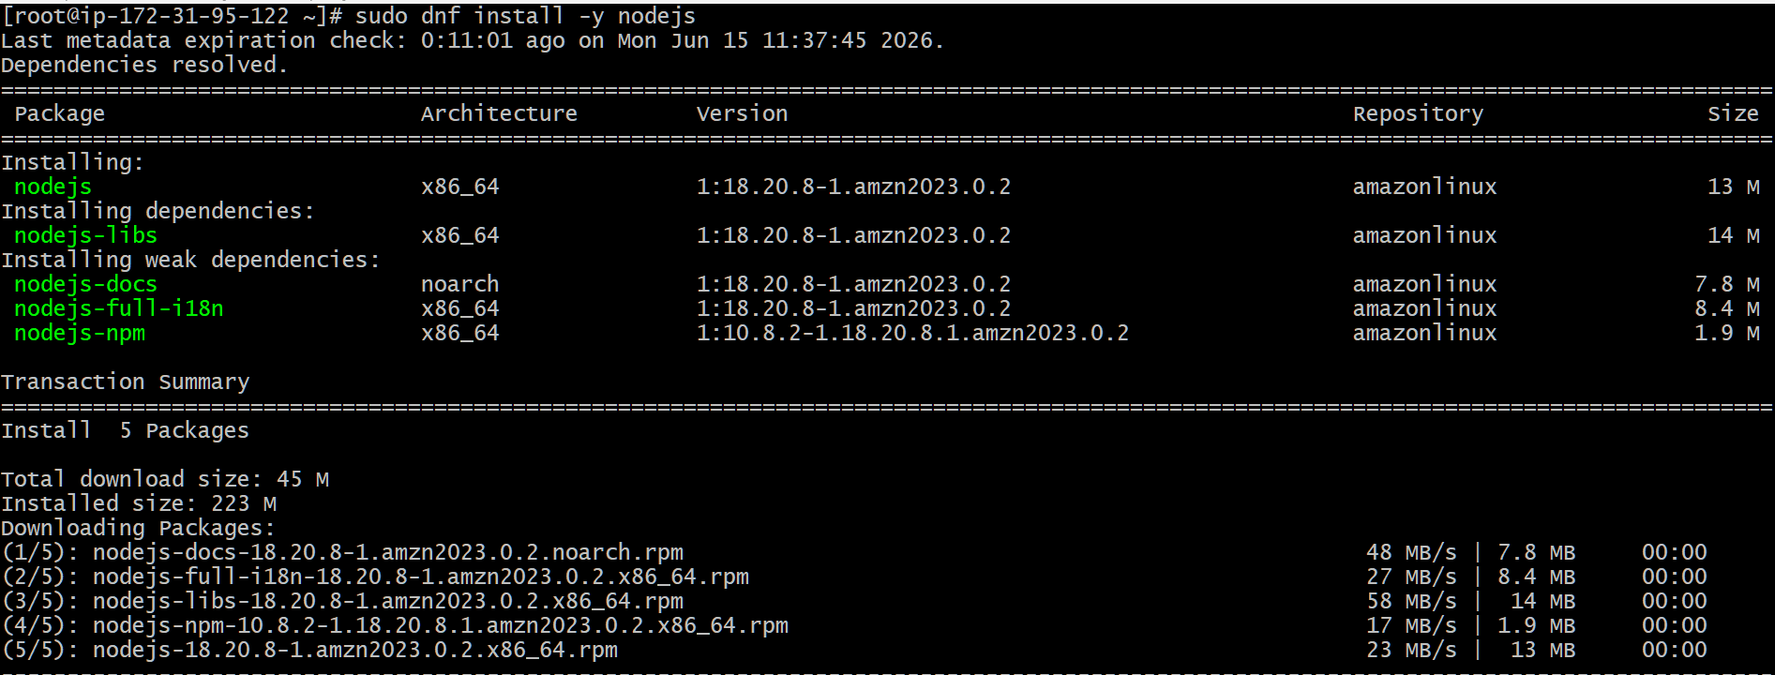
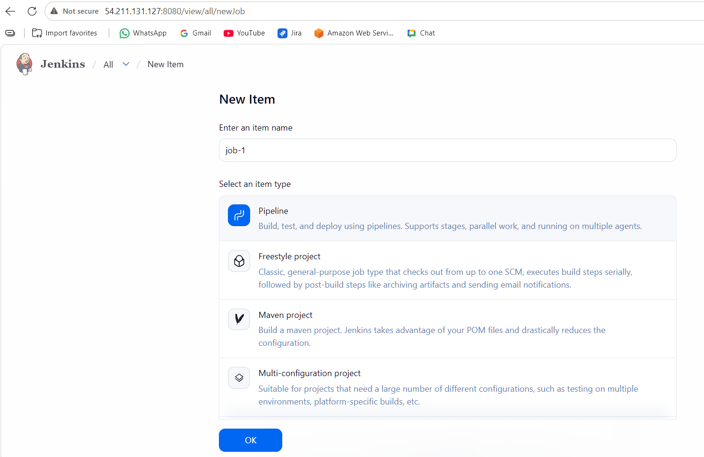
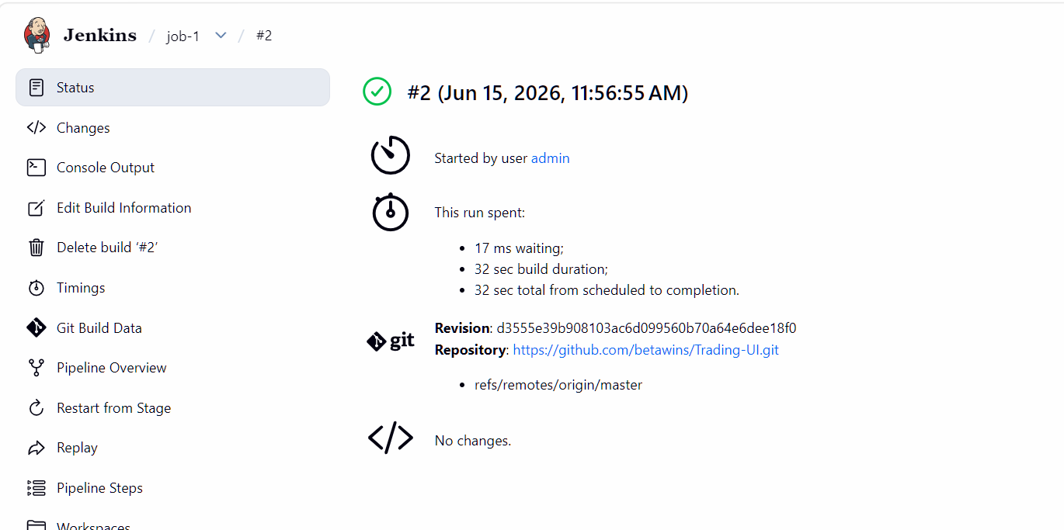
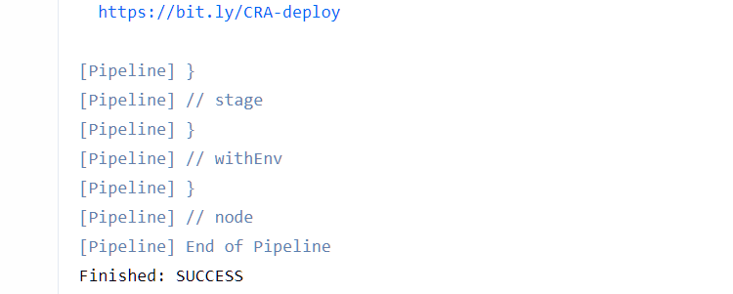
Let’s verify the packages
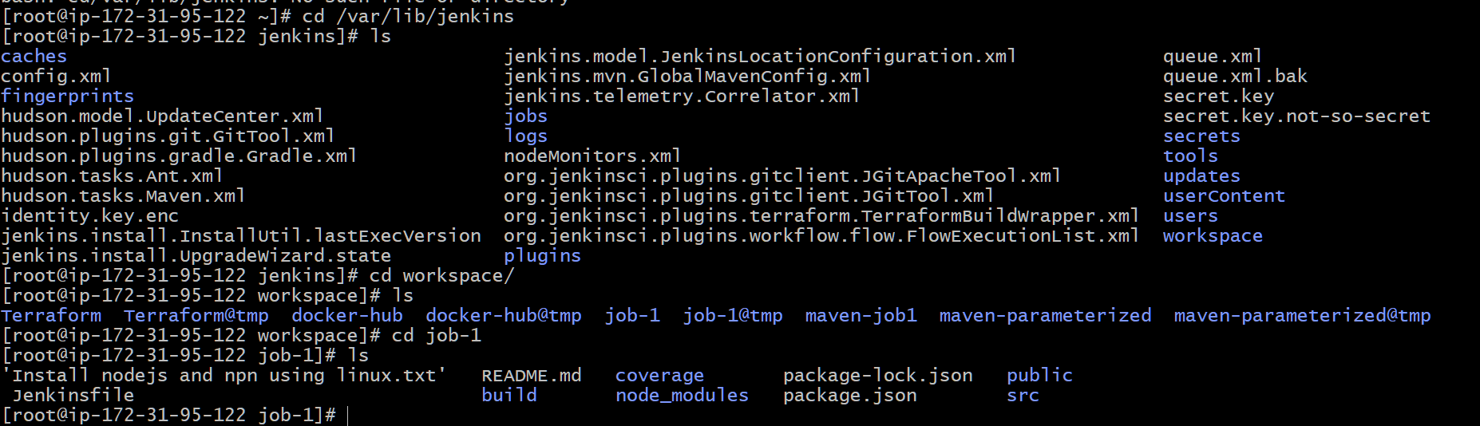

5). Explain 10 Maven commands.
mvn compile | Compiles the source code
mvn test | Runs unit test cases
mvn package | Creates JAR/WAR package
mvn install | Installs package into local Maven repository
mvn deploy | Deploys package to remote repository
mvn clean | Deletes previous build artifacts
mvn validate | Validates project structure and POM
mvn verify | Runs checks and integration tests
mvn dependency:tree | Displays project dependencies
mvn archetype:generate | Creates a new Maven project

